A leading retail company wants to better understand its customers shopping behaviour in order to improve sales, customer satisfaction, and long-term loyalty. The management team has noticed changes in purchasing patterns across demographics, product categories, and sales channels. They are particularly interested in uncovering which factors such as discounts, reviews, seasons, or payment preferences drive consumer decisions, and repeat purchases. You are tasked with analysing the company's customer behaviour data set to answer the following overarching business question.
How can the company leverage customer shopping data to identify trends, improve customer engagement, and optimize marketing and product strategies?

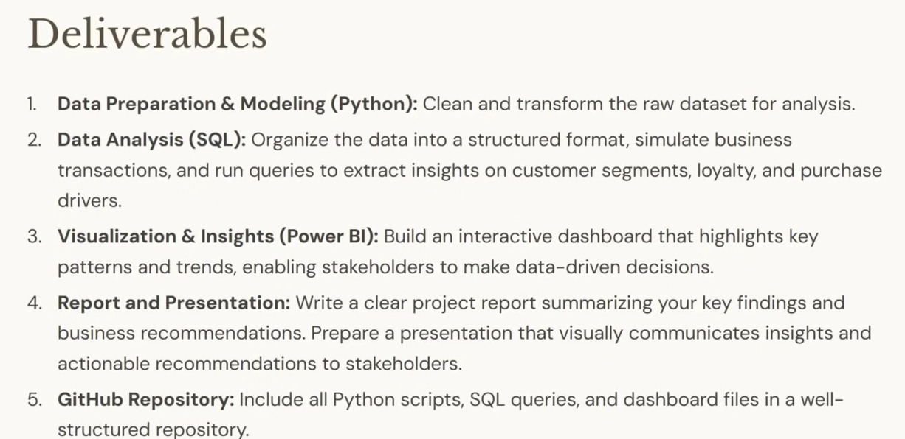

While cleaning data -> for missing values -> choose median over mean because mean can get affected by outliers and that would skew the distribution of our data. And why median? Because median is robust to outliers. Now what a common beginner will do here is just fill all the missing ratings with the overall median of the entire column and move on. And yes, that technically works, but it's not the best practice. Why? Because ratings can vary a lot depending on the category. Clothing category can have different review rating than footware category. Now, if we just take the overall median and fill it everywhere, we're basically forcing clothing items to get the same review ratings as footwear items. And that can introduce bias into our data set. Instead, what we will do is a little bit smarter than that. We will impute the missing values using the median review rating within each category. Please listen to this carefully. We will find out the median review rating within each category and will replace that with the missing value. That way if a clothing item is missing its review rating, it gets replaced with the median review rating of a clothing item, not a footwear item.

df['Review Rating'] = df.groupby('Category')['Review Rating'].transform(lambda x: x.fillna(x.median()))

Code | Meaning in simple words
df | Your entire dataset (table).
df['Review Rating'] | Select the Review Rating column.
= | Store the updated values in this column.
groupby('Category') | Separate the data into groups, such as Clothing and Footwear.
['Review Rating'] | Look only at the ratings within each group.
transform(...) | Apply the operation to each group and keep the results aligned with the original rows.
lambda x: | A short way of saying, "Take the current group's ratings and do the following."
x.median() | Calculate the median rating for the current category.
x.fillna(x.median()) | Replace missing ratings with that category's median.

# create a new column age_group to group customers into 4 age groups: young, adult, middle aged, senior
labels = ['Young Adult', 'Adult', 'Middle-aged', 'Senior']
df['age_group'] = pd.qcut(df['age'], q=4, labels=labels)

This code divides people into 4 age groups based on their ages and creates a new column called age_group.
Code | Meaning in simple words
labels | Create a list containing the names of the four age groups.
['Young Adult', 'Adult', 'Middle-aged', 'Senior'] | The four names we want to assign to the groups.
df | Your entire dataset (table).
df['age'] | Select the age column from your dataset.
pd.qcut(...) | Divide the ages into groups containing approximately equal numbers of people.
q=4 | Divide the data into 4 groups (quartiles).
labels=labels | Assign the names from the labels list to the four groups, in order from the lowest ages to the highest.
df['age_group'] | Create a new column called age_group.
= | Store the resulting age-group labels in this new column.

qcut() determines the age ranges from your actual data. It does not automatically know what ages count as young adult, adult, middle-aged, or senior.
Now what this Q cut does is it splits the ages into four equal-sized groups based on the data distribution and assigns the labels we defined.

df[['age', 'age_group']].head(10)

df | Your entire dataset (table)
[['age', 'age_group']] | Select two columns: age and age_group.
The inner square brackets ['age', 'age_group'] | Create a Python list containing the names of the columns you want.
The outer square brackets df[...] | Tell pandas to select the columns listed inside.
.head(10) | Display only the first 10 rows of the selected columns.

Next, let's create another feature called purchase frequency days. So right now the data set has a column called frequency of purchases which tells us how often a customer shops but it's in text form like weekly, monthly or quarterly and you know that working with text makes analysis harder especially if you want to calculate metrics or compare customers. So what we'll do is we'll convert these textual frequencies into numbers. Basically the number of days between purchases and this will help us make our analysis much easier.

# Create column purchase_frequency_days
# Dictionary named frequency mapping that maps each textual frequency to the equivalent number of days
frequency_mapping = {
'Fortnightly': 14,
'Weekly': 7,
'Monthly': 30,
'Quarterly': 90,
'Bi-Weekly': 14,
'Annually': 365,
'Every 3 Months': 90
}
df['purchase_frequency_days'] = df['frequency_of_purchases'].map(frequency_mapping)

First we created a dictionary called frequency mapping that maps each textual frequency to the equivalent number of days. Then we use a map function to replace the text in the column with the corresponding number of days.

df = df.drop('promo_code_used', axis=1)
In simple words, axis=1 tells pandas to work with columns, while axis=0 tells pandas to work with rows.

DATA EXPLORATION AND INITIAL DATA ANALYSIS DONE. NOW LOAD THE DATA SET INTO POSTGRES SQL SO THAT WE CAN RUN SQL QUERIES TO ANALYSE DATA AND ANSWER BUSINESS QUESTIONS.

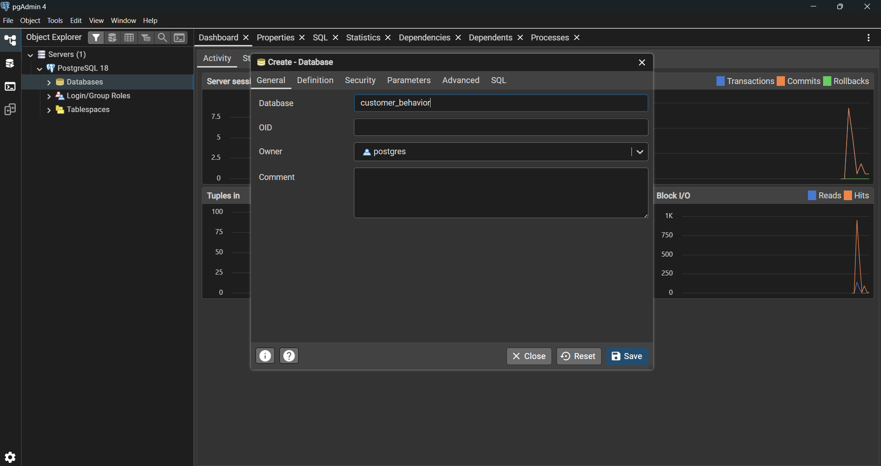

pip install psycopg2-binary sqlalchemy OR !pip install psycopg2-binary sqlalchemy

# connect jupyter notebook to postgres SQL
from sqlalchemy import create_engine
import pandas as pd

# PostgreSQL connection
username = "postgres"
password = "7777"
host = "localhost"
port = "5432"
database = "customer_behavior"

engine = create_engine(
f"postgresql+psycopg2://{username}:{password}@{host}:{port}/{database}"
)

# Write DataFrame to PostgreSQL
table_name = "customer"
df.to_sql(table_name, engine, if_exists="replace", index=False)

# Read back sample
pd.read_sql("SELECT * FROM customer LIMIT 5;", engine)

Code | Meaning in simple words
from sqlalchemy import create_engine | Import create_engine, a function used to establish a connection setup between Python and a database.
import pandas as pd | Import Pandas to work with tables and datasets. pd is its short name.
# PostgreSQL connection | A comment for humans. Python ignores it. It tells us that the next lines contain database connection details.
username = "postgres" | Store the database username in a variable called username.
password = "####" | Store the database password in a variable called password.
host = "localhost" | Specify where the database server is located. localhost means your own computer.
port = "5432" | Specify the port through which PostgreSQL accepts connections. 5432 is its default port.
database = "customer_behavior" | Specify the name of the database you want to connect to.
engine = create_engine(...) | Create a SQLAlchemy engine that holds the configuration needed to connect Python to PostgreSQL. It does not necessarily open the connection immediately.
f"postgresql+psycopg2://..." | Build the database connection URL. It tells SQLAlchemy to use PostgreSQL and the psycopg2 driver.
{username} | Insert the username stored in the username variable.
{password} | Insert the password stored in the password variable.
{host} | Insert the server location.
{port} | Insert the port number.
{database} | Insert the database name.
# Write DataFrame to PostgreSQL | A comment explaining that the next lines will save the dataset to the database.
table_name = "customer" | Store the name of the database table where you want to save your data.
df.to_sql(...) | Write the contents of your Pandas DataFrame df into a PostgreSQL table.
if_exists="replace" | If the table already exists, delete and recreate it. If it doesn't exist, create it.
index=False | Do not save the DataFrame's row index as an extra database column.
# Read back sample | A comment saying that the next line will retrieve a small sample of the saved data.
pd.read_sql(...) | Execute a SQL query and return the results as a Pandas DataFrame.
"SELECT * FROM customer LIMIT 5;" | Retrieve all columns (*) from the customer table, but return only the first 5 rows.
engine | Tell Pandas which database connection configuration to use to execute the query.
After this, the customer table will be visible in postgres SQL
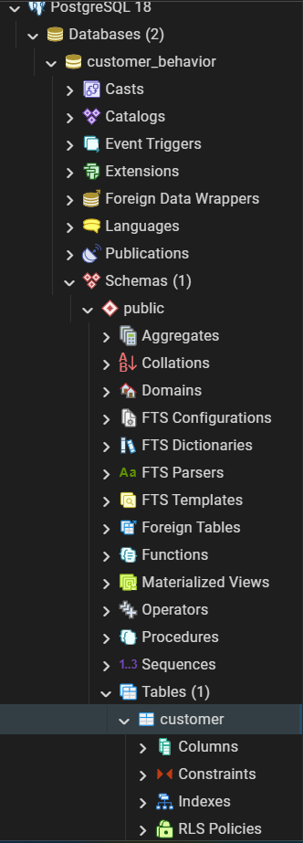

To run a query:
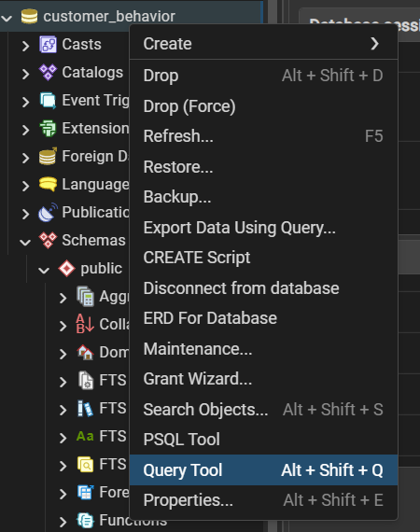

Business Questions: SQL Queries:

select * from customer

--Q1. What is the total revenue generated by male vs. female customers?
select gender, SUM(purchase_amount) as revenue
from customer
group by gender

--Q2. Which customers used a discount but still spent more than the average purchase amount?
select customer_id, purchase_amount
from customer
where discount_applied = 'Yes' and purchase_amount > (select AVG(purchase_amount) from customer)

--Q3. Which are the top 5 products with the highest average review rating? (::numeric -> cast into numeric form)
select item_purchased, ROUND(AVG(review_rating::numeric), 2) as "Average Product Rating"
from customer
group by item_purchased
order by avg(review_rating) desc
LIMIT 5;

--Q4. Compare the average Purchase Amounts between Standard and Express Shipping.
select shipping_type, ROUND(AVG(purchase_amount),2) as "Average Purchase Amount"
from customer
where shipping_type in ('Standard', 'Express')
group by shipping_type

--Q5. Do subscribed customers spend more? Compare average spend and total revenue between subscribers and non-subscribers.
select subscription_status, COUNT(customer_id) as total_customers,
ROUND(AVG(purchase_amount), 2) as average_spend,
ROUND(SUM(purchase_amount), 2) as total_revenue
from customer
group by subscription_status
order by total_revenue, average_spend desc;

--Q6. Which 5 products have the highest percentage of purchases with discounts applied?
select item_purchased,
ROUND(100 * SUM(CASE WHEN discount_applied = 'Yes' THEN 1 ELSE 0 END)/COUNT(*), 2) as discount_rate
from customer
group by item_purchased
order by discount_rate desc
limit 5;

--Q7. Segment customers into New, Returning, and Loyal based on their total number of previous purchases, and show the count of each segment.
with customer_type as (
select customer_id, previous_purchases,
CASE
WHEN previous_purchases = 1 THEN 'New'
WHEN previous_purchases BETWEEN 2 AND 10 THEN 'Returning'
ELSE 'Loyal'
END AS customer_segment
from customer
)

select customer_segment, COUNT(*) as "Number of Customers"
from customer_type
group by customer_segment

--Q8. What are the top 3 most purchased products within each category?
with item_counts AS (
select category, item_purchased,
COUNT(customer_id) as total_orders,
ROW_NUMBER() over(partition by category order by COUNT(customer_id) DESC) as item_rank
from customer
group by category, item_purchased
)

select item_rank, category, item_purchased, total_orders
from item_counts
where item_rank <= 3;

--Q9. Are customers who are repeat buyers (more than 5 previous purchases) also likely to subscribe?
select subscription_status,
COUNT(customer_id) AS repeat_buyers
from customer
where previous_purchases > 5
group by subscription_status

--Q10. What is the revenue contribution of each age group?
select age_group,
SUM(purchase_amount) AS total_revenue
from customer
group by age_group
order by total_revenue desc;

